**Functional Document**

|  |  |
| --- | --- |
| **Application** | NGERP - Centra |
| **Service Bundle** | Inventory Management |
| **Service Request** | Tally Sheet Confirmation |

**Description :**

Tally sheet confirmation is used to authorise the tally sheet transaction by an higher authority. User can able to increase the gift stock in warehouse by using tally sheet.

**Workflow Process :**

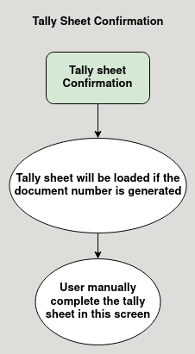

**Business Rules :**

* Tally sheet confirmation is accessible in both Region and HQ.
* The tally sheet will be loaded if the document status is completed, In tally sheet confirmation screen.
* User can able to void tally sheet in tally sheet confirmation screen both Region and HQ.
* User have to manually complete the tally sheet in tally sheet confirmation screen.